**Improvement on “Home” Page:**

Re-alignment & Re-design





**Home Services Our Team Contact**

**Your global gateway to**

**business process outsourcing**



**Your global gateway to**

**business process outsourcing**

Transist upon scrolling down

With short detailed description of the company

v





Home Services Our Team Contact



Short description here about the business offer

**Growing your business and helping with organizing**

Short description here about the business category

**Accounting Reports**





**Contact us**

C

**Growing your business and helping with organizing**

**Structured Assessment**

**General Consultancy**

**Financial Analysis**

**Accounting Reports**

Short description here about the business category

**Financial Analysis**

Short description here about the business offer

Short description here about the business category

Short description here about the business category

Short description here about the business category

Short description here about the business category



**Contact us**

C

Testimonials from client/s you’ve worked into before. This improves credibility and contributes to SEO (SERPS). Design is subject to change on most appropriate.

v



Home Services Our Team Contact

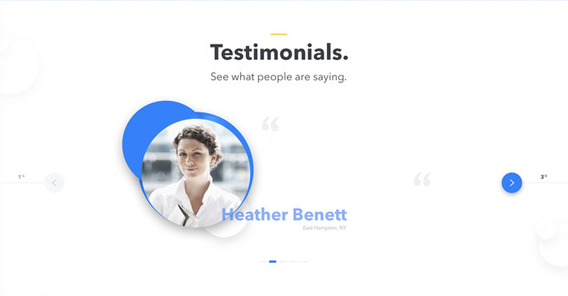



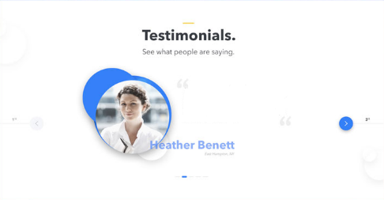

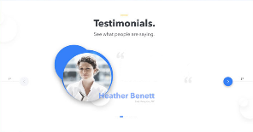

Paragraph here testimonial testimonial testimonials testimonial asdf asdfasdf asdfasdfasdf asdfsad asdf

Paragraph here testimonial testimonial testimonials testimonial asdf asdfasdf asdfasdfasdf asdfsad asdf

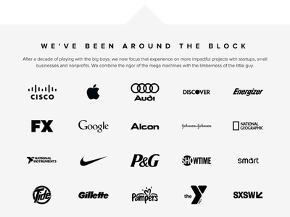

Some list of clients you’ve worked with in your business, displayed in the page. Improves credibility. Colors when hovered by a mouse cursor.

v







Home Services Our Team Contact





Paragraph here testimonial testimonial testimonials testimonial asdf asdfasdf asdfasdfasdf asdfsad asdf







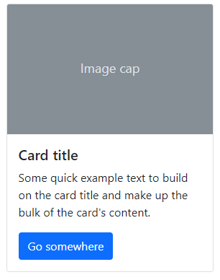



Engagement to improve User Experience by inserting short blogs to the home page and redirecting visitors to the blog page to see more and interacts. This contributes to SEO (SERPS).

E. g. Short blogs or articles related to your business/services.





Home Services Our Team Contact





**Improvement on “Services” Page:**

Introductory overview of your Services Page

v







Home Services Our Team Contact



Our Services

Reliability &

Accuracy

Our Services

Reliability &

Accuracy

We perform a variety of financial and accounting services, and offer you the maximum flexibility by allowing you to rely on us for any of the services that we offer as needed.

We perform a variety of financial and accounting services, and offer you the maximum flexibility by allowing you to rely on us for any of the services that we offer as needed.

**Featured Service**

**Featured Service**

Featured Services about your business that looks appealing to your clients

v

upon going to the Services Page.





Home Services Our Team Contact

**Featured Service**



**“You’ve never seen your revenue like this before.”**





**“You’ve never seen your revenue like this before.”**

**Featured Service**



**MONTHLY / ANNUAL PREPARATION & FINANCIAL STATEMENT ANALYSIS**

**MONTHLY / ANNUAL PREPARATION & FINANCIAL STATEMENT ANALYSIS**

Some descriptions about that featured service that you help a client improve their business

Some descriptions about that featured service that you help a client improve their business

Categorize the existing services offered with some related images to help visually communicate those services to the target audience.

v





Home Services Our Team Contact





**U.S. Tax Return**

**Preparation**

**Operations Credit &**

**Underwriting**

**Accounting &**

**Finance**

**Portfolio**

**Management**



[This Photo](http://capreform.eu/two-steps-forward-one-step-back-coupled-payments-in-the-cap/) by Unknown Author is licensed under [CC BY-SA](https://creativecommons.org/licenses/by-sa/3.0/)

**Accounting & Finance**

1.Preparation of weekly & monthly forecasts

2.Preparation of monthly board reports

3.Monthly/yearly preparation and analysis of financial statements

4.Monthly/quarterly preparation of compliance reports



[This Photo](http://capreform.eu/two-steps-forward-one-step-back-coupled-payments-in-the-cap/) by Unknown Author is licensed under [CC BY-SA](https://creativecommons.org/licenses/by-sa/3.0/)



[This Photo](http://capreform.eu/two-steps-forward-one-step-back-coupled-payments-in-the-cap/) by Unknown Author is licensed under [CC BY-SA](https://creativecommons.org/licenses/by-sa/3.0/)



[This Photo](http://capreform.eu/two-steps-forward-one-step-back-coupled-payments-in-the-cap/) by Unknown Author is licensed under [CC BY-SA](https://creativecommons.org/licenses/by-sa/3.0/)



[This Photo](http://capreform.eu/two-steps-forward-one-step-back-coupled-payments-in-the-cap/) by Unknown Author is licensed under [CC BY-SA](https://creativecommons.org/licenses/by-sa/3.0/)

1.Preparation of weekly & monthly forecasts

2.Preparation of monthly board reports

3.Monthly/yearly preparation and analysis of financial statements

4.Monthly/quarterly preparation of compliance reports

1.Preparation of weekly & monthly forecasts

2.Preparation of monthly board reports

3.Monthly/yearly preparation and analysis of financial statements

4.Monthly/quarterly preparation of compliance reports

1.Preparation of weekly & monthly forecasts

2.Preparation of monthly board reports

3.Monthly/yearly preparation and analysis of financial statements

4.Monthly/quarterly preparation of compliance reports

1.Preparation of weekly & monthly forecasts

2.Preparation of monthly board reports

3.Monthly/yearly preparation and analysis of financial statements

4.Monthly/quarterly preparation of compliance reports

**Adding “Blog” Page for more engagement:**

Categorized Blog lists

v

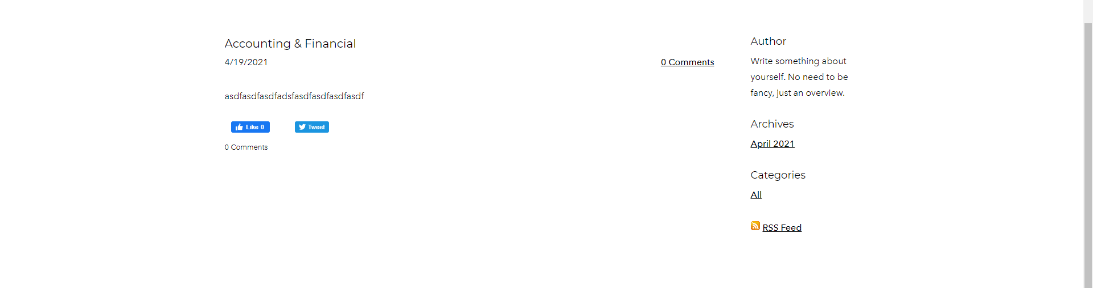

Enabled interactions (this improves contents that may help on search engine optimization)

v

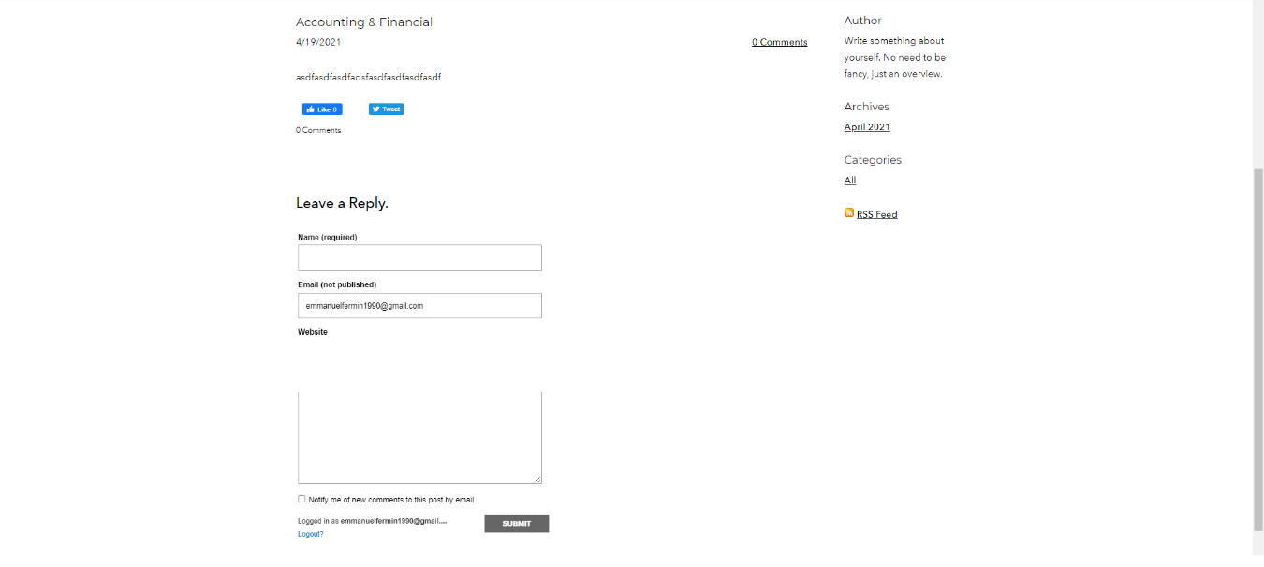

**Improvement for “Our Team” page:**

Re-alignment and redesign to look sleek.

v



**Tony Razon**

- Chairman and CEO

Tony Razon is the Chairman and CEO of VFP Business Support Services, Inc. He has a vast experience and leadership in the BPO industry since 2007. Prior to joining VFP BSSI, he was Vice President – Operations Manager of First Capital’s subsidiary in Manila. Mr. Razon has over 25 years of significant U.S. asset- based lending and factoring experience at Heller Financial Corporation, Congress Financial Corporation, Fleet Capital and Capital Business Credit based in Los Angeles, California



- Consultant

**Donald Felbaum**

Don has more than 30 years of diversified leadership experience in general management, business development, strategic planning and corporate directorship. He has a proven track record throughout the Asia Pacific region. In addition. Mr. Felbaum has lived and worked in Manila, Philippines for over 30 years. He currently sits as a board director of the American Chamber of Commerce of the Philippines (AMCHAM), adviser to the Pacific Telecommunications Council (PTC) and member of other esteemed boards.

**Improvement for “Contact” Page:**

Adding validation to avoid spam emails (security feature).

v

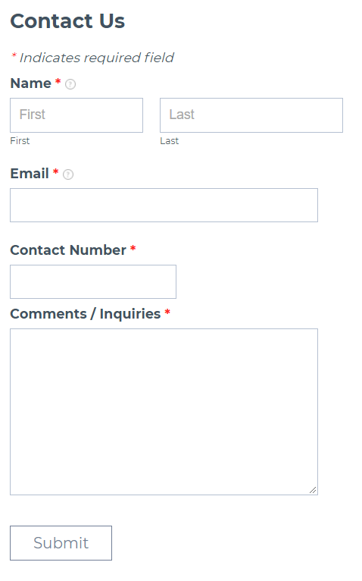



**GOOGLE SEARCH ENGINE OPTIMIZING YOUR WEBSITE**

1. **Introduction**

Google uses Googlebot, a web crawler software which collects docs from the web to build a searchable index for the Google Search Engine.

1. **How do I get my site into Google?**

Crawling & indexing are processes which can take some time and which rely on many factors. If you want to know more visit here (if not, you may continue down below).

The process can be a little slow at first, and the reports lag a little too, usually it takes about a week or two show the “index coverage report”. [...know more](https://developers.google.com/search/help/crawling-index-faq)

1. **What I will do?**
2. Adding your website in Google Search Console helps in Search Engine Optimization by generating significant information about your website which we can also use on to improve the website further. [...know more](https://developers.google.com/search/docs/beginner/get-started)

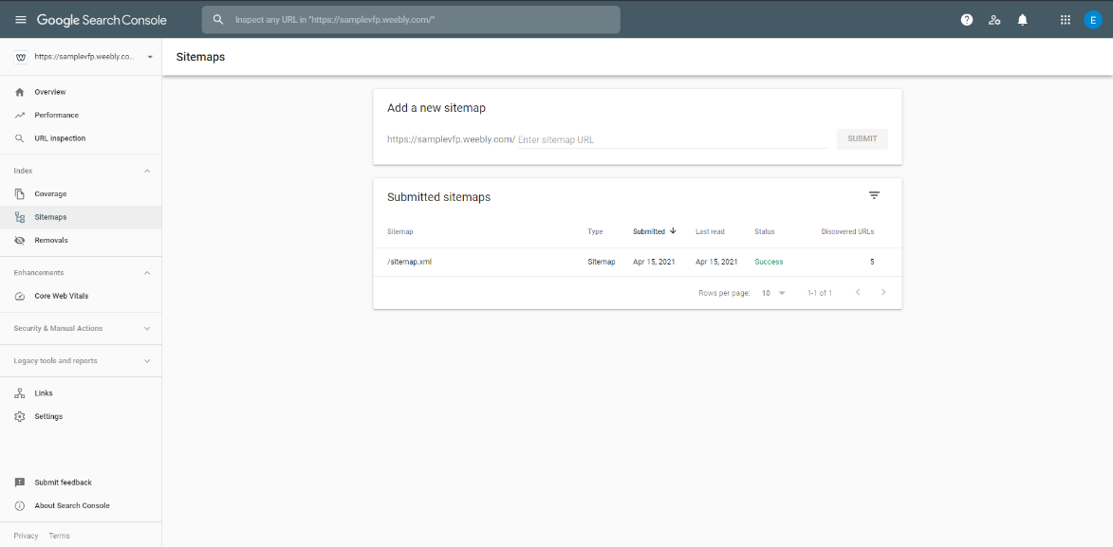

**Performance on search results:**

*Clicks:*  Count of clicks from a Google search result that landed the user on your property.

*Impressions:* The number of times any URL/LINKS from your site appeared in search results viewed by a user, not including paid Google Ads search impressions.

*Average Position:* The average ranking of your website URLs for the query or queries. For example, if your site’s URL appeared at position 3 for one query and position 7 for another query, the average position would be 5 ((3+7)/2).

*CTR (Click-through-rate):* the click count divided by the impression count.

and *top query keywords* used by users to search your website

1. Initially, we’ll find the most searched keyword in [Google Trends](https://trends.google.com) and make a content out of it. (Tip: updating your website regularly helps you get on top ranks in Search Engine Result Pages. Usually businesses hire a Content Manager for researching, sourcing, writing, and editing interesting content focusing on services offered to be published for end-users.)

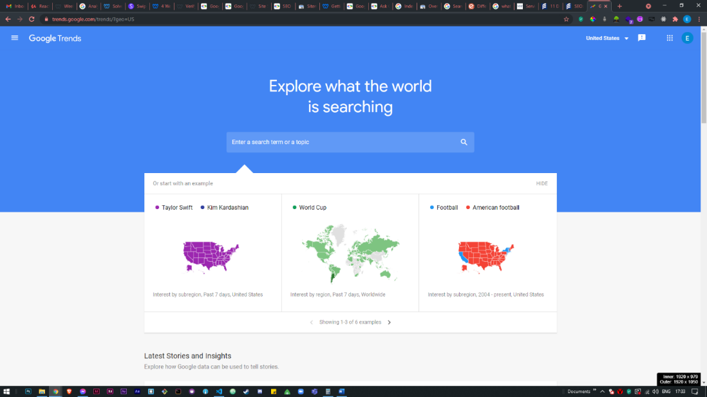

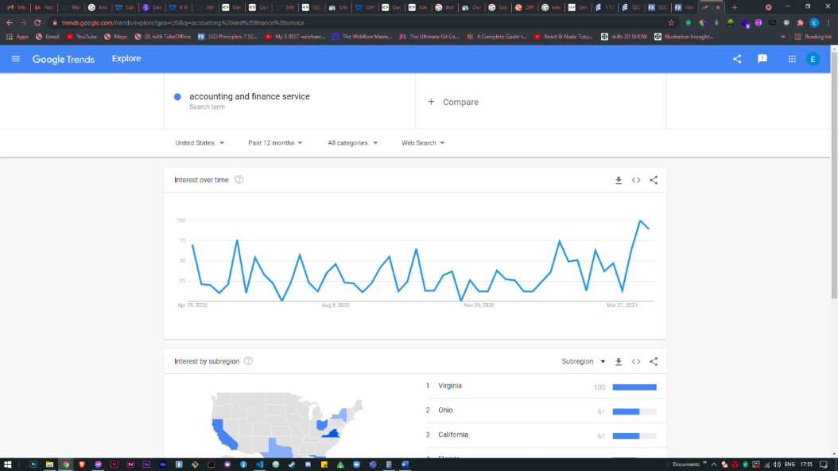

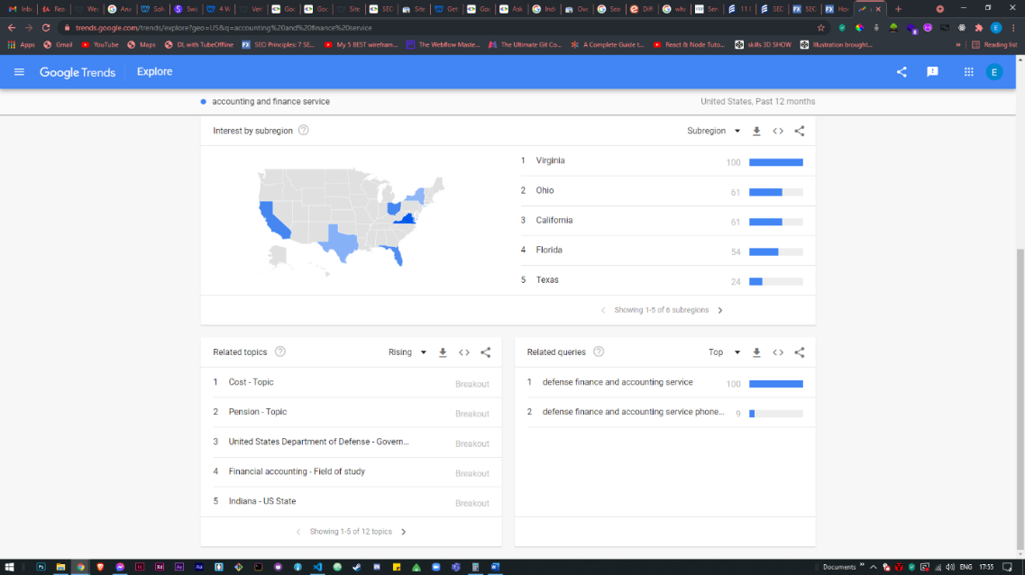

1. Re-design your website to look more professional and SEO-focused

* Adding meta descriptions to the images of your website so Google can index images, too.
* Adding more content & good design to keep visitors engage. In fact, [38% of users will leave a site](https://learn.g2.com/web-design-statistics) if they don’t like the design & user experience. Able to keep users on-site longer is good for SEO.

1. I’ll assist you to get listed on Google Maps (this also improves ranking of your website) *optional*

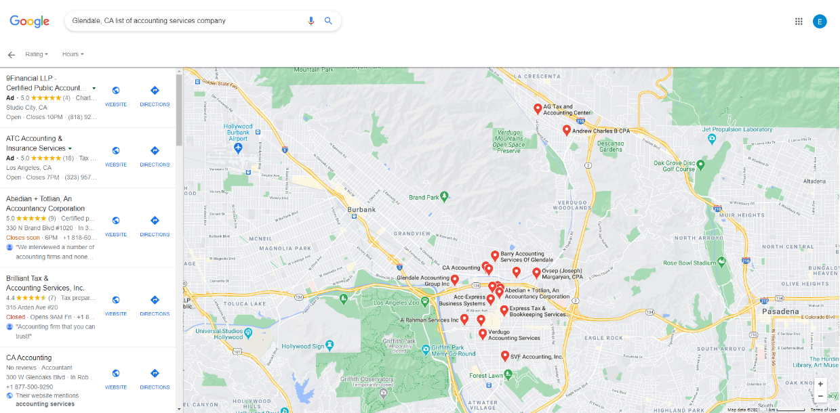

Follow these steps and officially register your business (This also improves local search).

[Create your Business Listing in Google Maps](https://support.google.com/business/answer/6300717).



[This Photo](https://commons.wikimedia.org/wiki/File:Google_Material_Design_info_outline.svg) by Unknown Author is licensed under [CC BY-SA](https://creativecommons.org/licenses/by-sa/3.0/)

*Why you?*

* *You are required to enter your Business Information*
* *You may also be asked to position a marker to your precise location (main or chain office). Don’t worry it can be change inside your account.*
* Google will send you a snail-mail of your postcard which includes a unique verification code that you must enter in [Google My Business](https://business.google.com/create) to confirm that your business is located at the listed address.

Then, add photos to your listing to give people a visual insight into your business. This step is valuable because companies with photos receive 42% more requests for directions and 35% more clicks to their websites than companies without pictures. [how?](https://support.google.com/business/answer/6335804)

After these steps, you’ll have a polished Google My Business listing that will start driving local traffic. 930780775 108030

**SUMMARY OF PROJECT:**

$ 400

1. Website Overhaul – completion in 7 days

(around 46-hrs)

• SEO focused Web design

• Initial content composition

• User Interface/User Experience design

$ 150

1. Google SEO – completion in 14-days

Requires 14-days due to monitoring &

waiting for the release of report

• Website Audit & report

• Index Optimization

• XML Sitemap (So that google indexes your website)

• Compress media (via Google Page Speed Insights tool)

$ 550

TOTAL : 21 days completion